Data Sharing

## Sharing Data from Parent Component to Child Component

1. We can share the data from parent component to child component using “Property Binding”
2. Assign the value to “Parent Component’s Property” to “Child component’s property”, using Property Binding
3. Set @input() for child component property to accept value from parent component’s property. You can import “input” from the “@angular/core” package.

import “input”:

Import {input} from “@angular/core”

Step 1:

Create a new application in angular

ng new app1-data-share

Step 2:

Create two components called Employee and Company

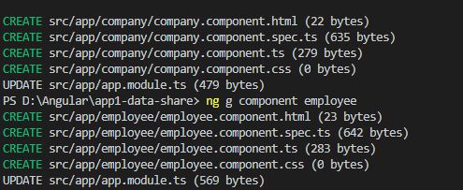

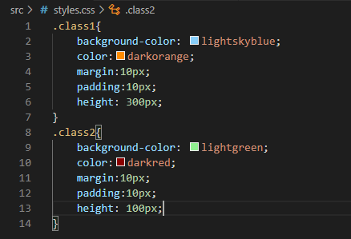

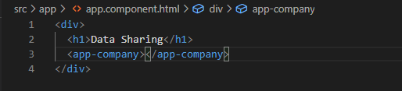

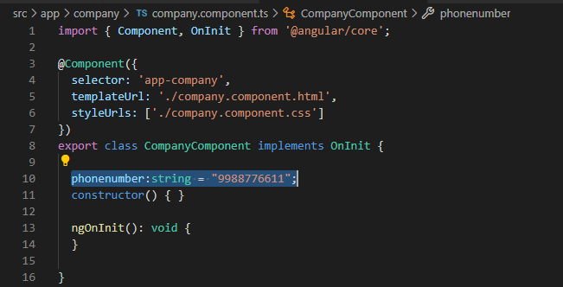

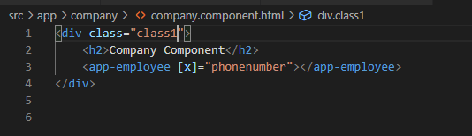

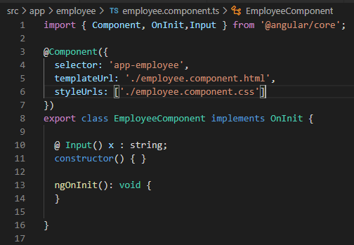

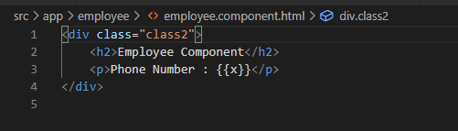

ViewChild Example:

Create a new application app1-viewchild-exmple

Create two components as company and employee

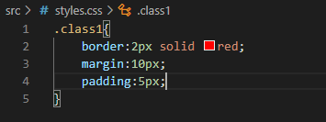

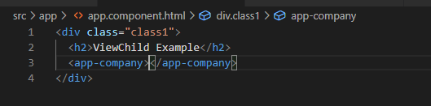

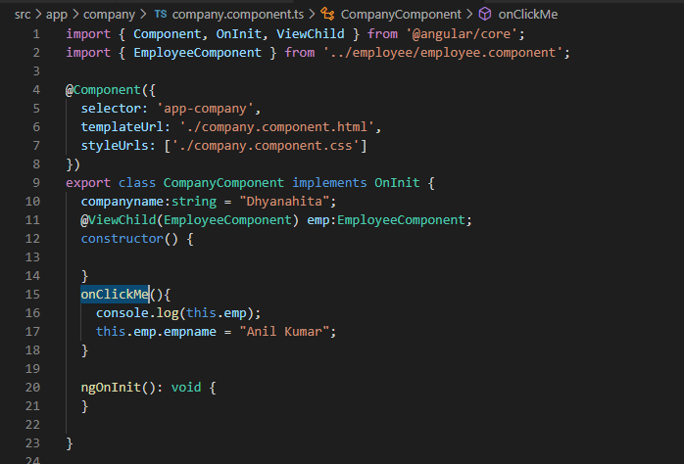

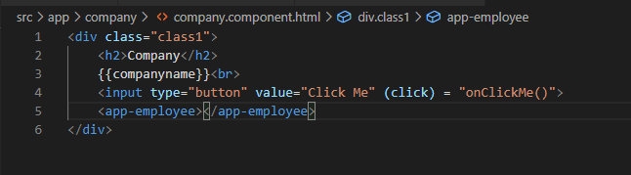

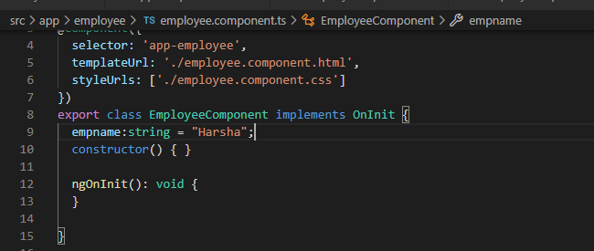

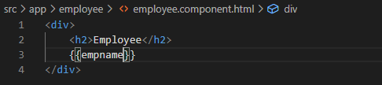

## View Childrens:

1. The “ViewChildren” represents a set of elements of specific type, which is a child of the view {template} of the component
2. ViewChildren is used to access elements, that is present in the view {template} of the component
3. ViewChildren is used to access properties / methods of the children

Steps:

Import “ViewChildren” and “QueryList”

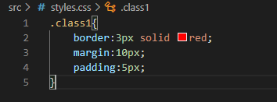

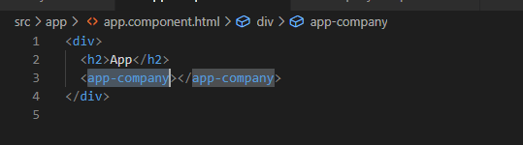

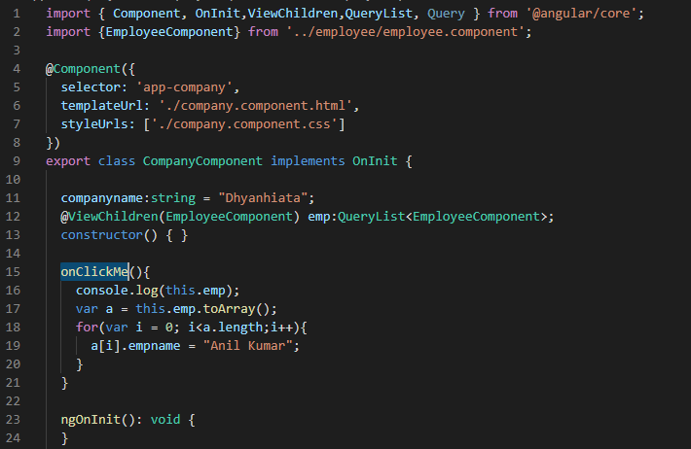

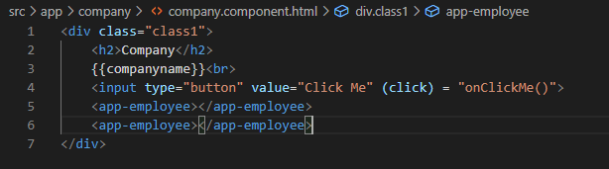

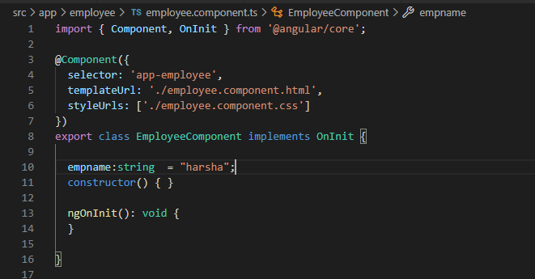

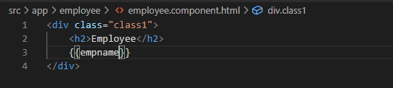

Life Cycle Hooks: